N.J. Doo Wop & A cappella Society with VGHA Presents
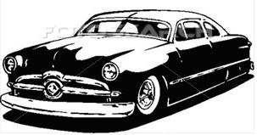
Classic Car
& Truck Show to Benefit
Prostate Cancer Research
plus live Doo Wop & A cappella at
The Hearth Restaurant
Everyone is welcomed for a day of great music and classic cars!
Sun. Oct. 19th 2014 10 am - 3 pm
(Rain or shine, this is an indoor/outdoor event)
See and Listen to Singers performing hit songs from the 50’s 60’s & 70’s
Hosted by DJ Nick at Nite & Friends
Reg. $10 for Classics Open Mic $5 donation
Prizes * Trophies * Free Parking
Open to all Cars & Trucks * No Bikes/Pets Please
The Hearth Restaurant Rt. 46 W. Clifton NJ (near Rt. 3 & GSP Fette Ford) Info (201) 303-3218

